Read Me

Files:

Question 1 : Normal Equation regularized

<https://www.kaggle.com/muditr97/assignment-2-normal-equation?scriptVersionId=11520001>

Question 2 : Gradient Descent Regularized   
<https://www.kaggle.com/muditr97/assignment-2-gradient-descent-regularized?scriptVersionId=11529978>

Data Set: Housing Price Data set Provided

The Assignment where done on Jupyter Notebook  
FileName for Normal Equation : Assignment_2_NormalEquationRegularized  
FileName for Gradient Descent : Assignment_1_GradientDescentRegularized

Open the file which ( is public ) add this to jupyter Notebook, Data set Name : “ Housing Price data set “ and run the code.  
It will produce the error for Normal Equation(root mean squared error) and for Gradient Descent Algorithm(root mean squared error)

Libraries used :

1. NumPy
2. SciPy
3. Pandas
4. Os
5. Sklearn

Data Set Highlights:

1. 546 Training Examples
2. 12 Features Independent
3. Price as dependent Variables

Analysis for Assignment 2 for Regularized Linear Regression

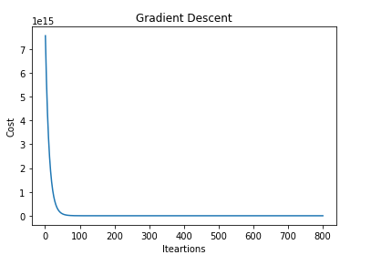

The above Curve shows us the relationship for the Cost and the number of iterations for the Gradient Descent Algorithms.

The Root mean Squared Error:

1. Normal Equation Regularised:  
   **18022.61818566**
2. Gradient Descent Regularized:   
   **15776.2343929**

From the above result we can see that the root mean squared error that we have calculated for the Normal Equation and the Gradient Descent we have a lower error for the Gradient Descent Algorithm

Also we have to typecast various parameters in order to be precise for the calculations.